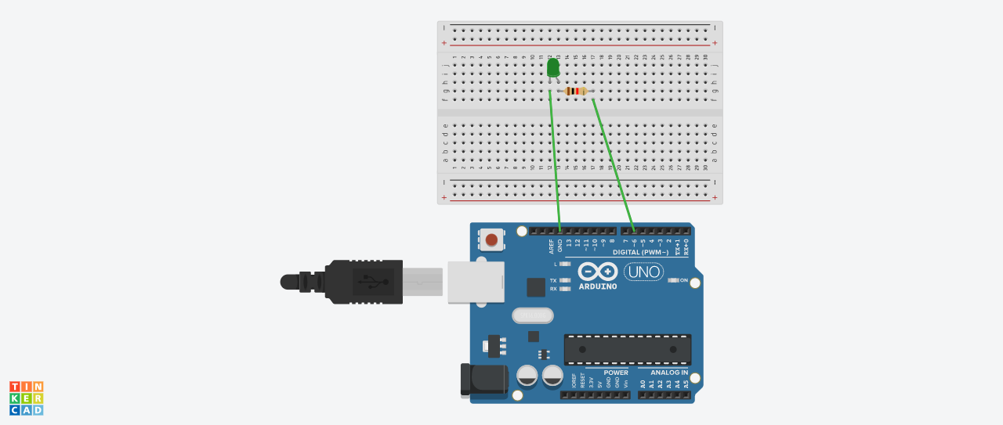

***THEORY***

***CONCEPT USED***:

Basic Concept and knowledge of arduino and its working , knowledge of working in arduino software and coding or programming on the software , Knowledge of circuit in order to connect various elements to the arduino like led , wireS , etc.

***LEARNING AND OBSERVATION:***

Learning- learning to connect the led to the breadboard and that to arduino and the coding used.

Observations- observed the working of arduino software and hardware and the blinking of led using arduino.

***PROBLEM AND TROUBLESHOOTING:***

Problems in making proper circuit with breadboard using the proper series combination. Problem in ports of arduino.

***PRECAUTIONS:***

Using proper working leds and wires

Connecting and working properly with arduino

Using safty measures

***LEARNING AND OUTCOMES:***

Learning working with arduino and coding in arduino software , Working with breadboard , and understanding arduino boards.